# Setup GIT in your Local system

## #1 Installing GIT in local

1. Download the Windows 64-bit installer from the below location.

<https://git-scm.com/download/win>

1. Use all the default options to install GIT in the local system.
2. Confirm that GIT is installed, by executing the below command in PowerShell or command prompt.

git --version

The expected output should look below

git version 2.33.0.windows.2

## #2 Creating a GitHub account

If you already have a GitHub account, you can skip this section and move to #3

1. Go to the below link

<https://github.com/signup>

1. Fill out the required details and create an account.

## #3 Forking a repository

1. Go to the below link

<https://github.com/saurav-samantray/flask-microservices-training/>

1. Click on the fork button to fork the repository.

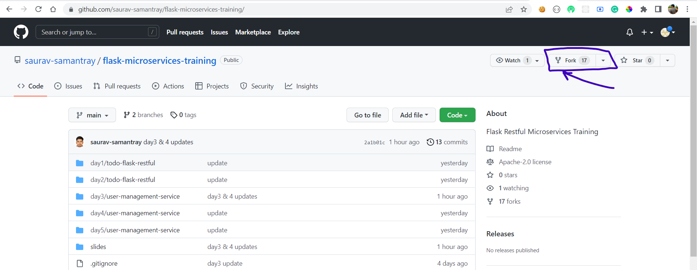

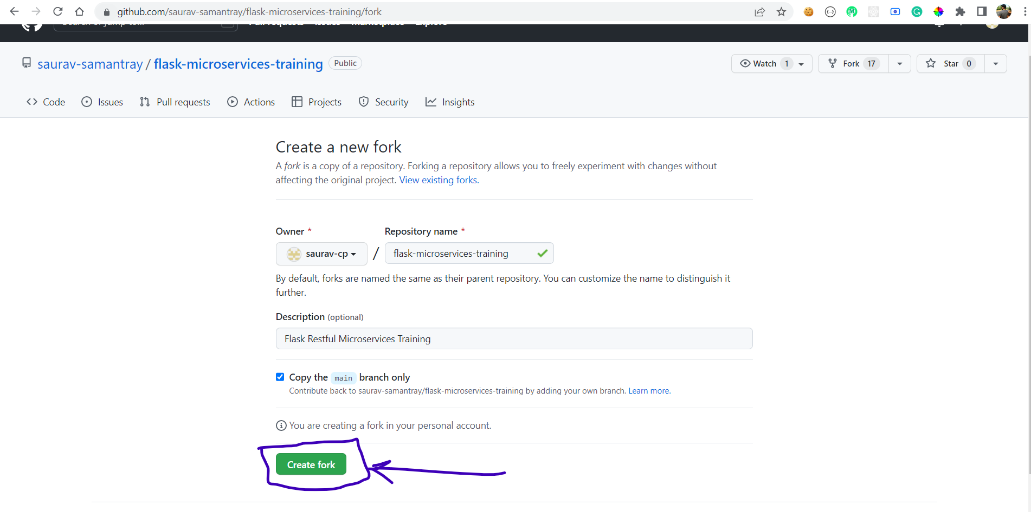

## #4 Cloning the forked repository to your local

1. Copy the HTTPS link from your forked repository. Screenshot reference below.

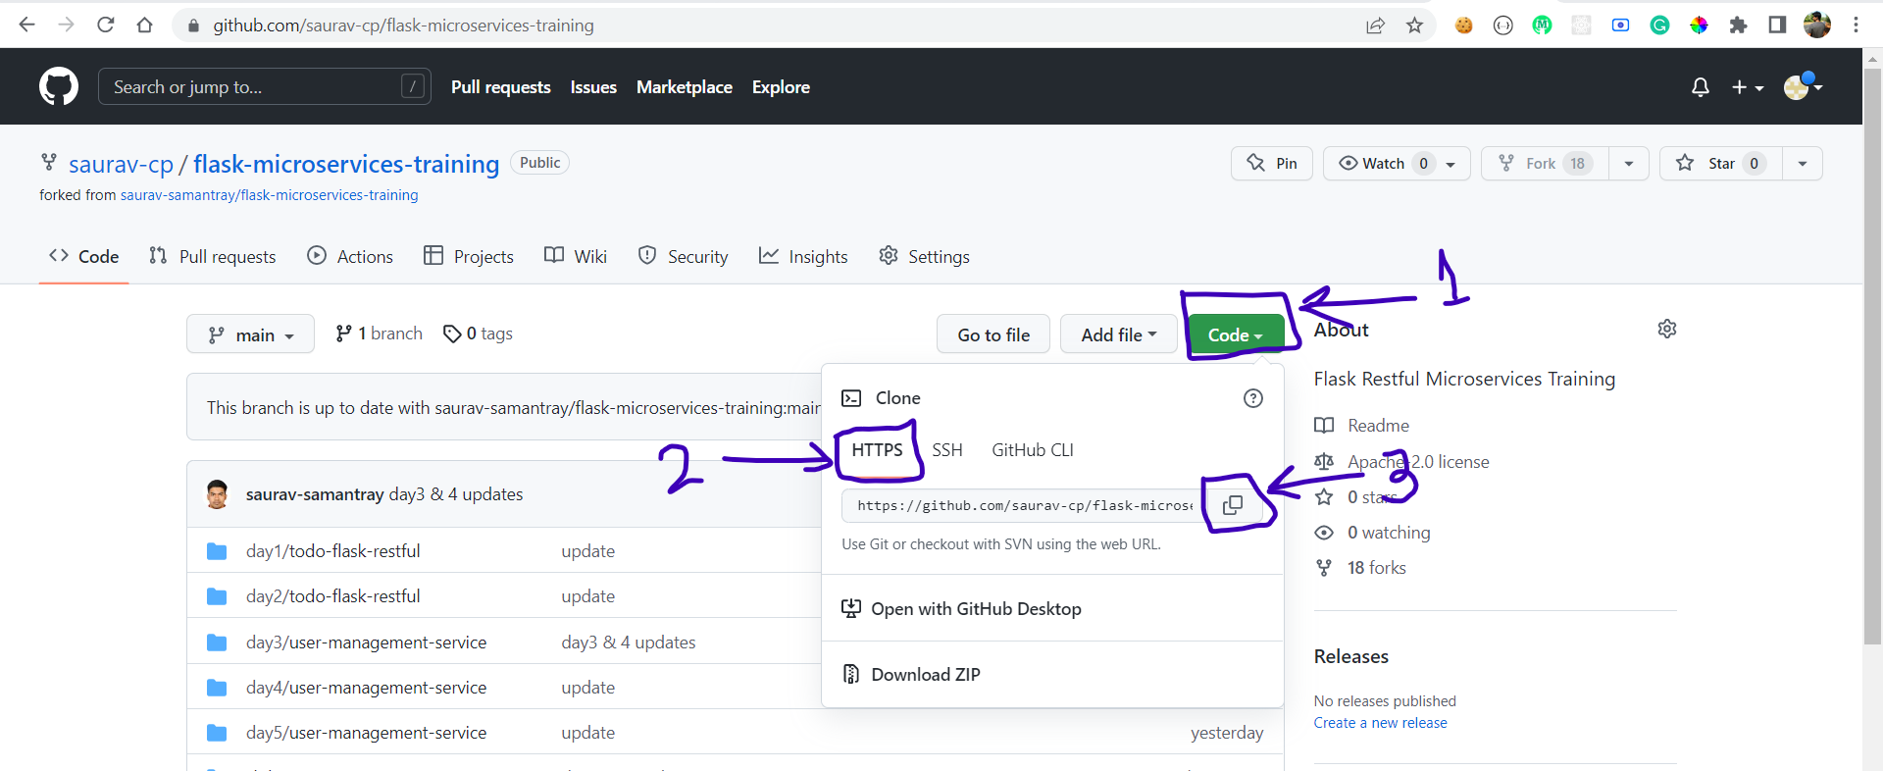

1. Open Powershell or command prompt and navigate to your workspace folder. If you dont have one, create a workspace folder under C drive.

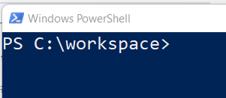

1. Execute the below command to clone the repository that was copied in step number 1.

**git clone https://github.com/<your-username>/flask-microservices-training.git**

## #5 Syncing a fork to get updates

1. Perform the Sync Fork action from GitHub. Reference screenshot below.

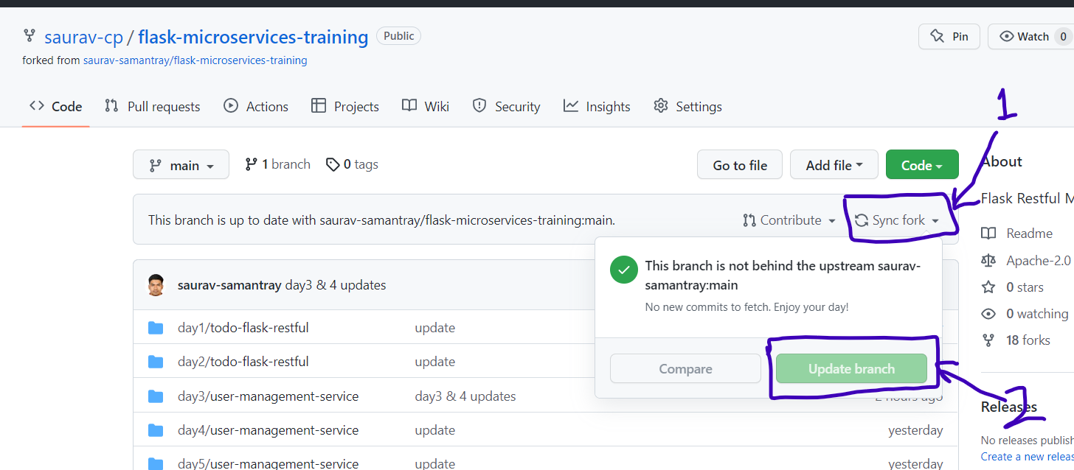

1. Navigate to the folder in PowerShell or Command Prompt and execute **git pull** command.

